HYBRID IMAGE DEBLURRING USING GAN’S AND SRN’S: A DEEP LEARNING APPROACH

ABSTRACT

Image Deblurring plays a vital role in multiple fields including photography, medical imaging, surveillance and so on. Traditional methods lack generalization of different types of blur and are also computationally intensive. In this project, a hybrid Generative Adversarial Network(GAN) combining the Super-Resolution Network(SRN) Generator and PatchGAN Discriminator is utilized for obtaining the robust and efficient solution of image deblurring. The SRN is intended to learn from the training images and restore the details without using any artifacts that are utilized in the conventional methods. At the mean time the discriminator gives feedback about the images produced by the generator and helps the generator to produce high quality ,sharp images. The dataset utilized for training and evaluation is GoPro dataset, which consist of pair of sharp and blur images. The developed model uses Mean Squared Error(MSE) and binary cross entropy for the generator and discriminator respectively. Peak signal to Noise Ratio and Structural Similarity Index are utilized for performance evaluation of the model. The hybrid model is compared with the Standalone model of SRN and GAN using the metrices of PSNR and SSIM. The model uses an effective, adaptable and computationally efficient approach for image deblurring utilizing SRN and PatchGAN to obtain enhanced performance.

Contents
CONTENTS 0
LIST OF FIGURES 4
LIST OF ACRONYMS 5

CHAPTER 1

- INTRODUCTION...............................................................................................6
  - Introduction .............................................................................................6
  - PROBLEM STATEMENT .....................................................................6

  - OBJECTIVES .........................................................................................6
  - SCOPE OF THE PROJECT ....................................................................6

  - IMAGE DEBLURRING .........................................................................7

  - TYPES OF BLUR ..................................................................................7
    - Motion Blur ..........................................................................7
    - Gaussian Blur .......................................................................7
    - Out-of-Focus Blur ................................................................8

    - Radial Blur ...........................................................................8
    - Atmospheric Blur (or Haze Blur) .......................................8

Chapter 2

- Literature Review .............................................................................................10
  - LITERATURE GAPS ...........................................................................10

  - SURVEY PAPERS ...............................................................................10
  - MODEL ADVANTAGE .......................................................................12

Chapter 3

- Proposed Methodology ....................................................................................13
  - GAN ARCHITECTURE ...............................................................13

  - SRN GENERATOR.......................................................................14

  - PATCHGAN DISCRMINATOR ..................................................15

Chapter 4

- Dataset ...............................................................................................................16
  - GOPRO DATASET ..............................................................................16
  - DATA IMPORTATION AND SPLITTING ........................................16

Chapter 5

- Implementation .................................................................................................16
  - MODEL DESIGN .................................................................................16

    - SRN Generator ...................................................................16

    - PatchGAN Discriminator ...................................................17

    - GAN ...................................................................................17
  - LOSS FUNCTIONS ..............................................................................18

    - Mean Squared Error(MSE) ...............................................18

    - Binary Cross Entropy Loss ................................................18

  - OPTIMIZER AND LEARNING RATE ...............................................18

    - Adam Optimizer.................................................................18

    - Learning Rate .....................................................................19

  - TRAINING PROCESS .........................................................................19

    - Training Loops ...................................................................19

    - Epoch count and Batch size ...............................................19

  - EVALUATION METRICS ...................................................................19

    - Peak Signal to noise Ratio .................................................19

    - Structural Similarity Index Measure ..................................19

Chapter 6

- Challenges and Solutions ..................................................................................20
  - MODEL TRAINING AND CHALLENGES ........................................20

    - Computational Constraints.................................................20

    - Overfitting ..........................................................................20
    - Stability ..............................................................................20
  - REAL WORLD VARIATIONS ...........................................................21

    - Model Generalization.........................................................21

    - Diverse types of blurs ........................................................21

Chapter 7

- Result And Inference ........................................................................................22
  - REAL WORLD VARIATIONS ...........................................................22

  - VISUAL QUALITY AND REALISM .................................................23

  - COMPARISON WITH BASELINE MODELS....................................23

  - COMPUTATIONAL EFFICIENCY ...................................................23

Chapter 8

- Conclusion .........................................................................................................25
  - OUTCOME ...........................................................................................25

  - EFFICIENCY ........................................................................................25

  - FUTURE APPLICATIONS ..................................................................26

Chapter 9

- Future Works ....................................................................................................26
  - IMPROVING MODEL ROBUSTNESS ...............................................26

  - EXPLORING EFFECTIVE AND EFFICIENT

ARCHITECTURES ..............................................................................26

  - MODEL INTEGRATION ....................................................................26

  - REAL-TIME VIDEO PROCESSING ..................................................27

  - HYPERPARAMETER OPTIMIZATION ............................................27

APPENDIX 1 ...........................................................................................................28
REFERENCES ........................................................................................................40

LIST OF FIGURES
1.1 Blur Types ................................................................................................................ 10
1.2 GAN Architecture ..................................................................................................... 15
1.3 SRN Architecture ..................................................................................................... 16
1.4 PSNR comparison ..................................................................................................... 23
1.5 SSIM Comparison .................................................................................................... 24

LIST OF ACRONYMS

GAN - Generative Adversarial Network
SRN - Super Resolution Network
DCT - Discrete Cosine Transform
FPN - Feature Pyramid Network
HFAR - High-Frequency Attention Residual
FCA - Fourier Channel Attention ESA - Edge Spatial Attention
cGAN - Conditional Generative Adversarial Network MBD-GAN - Model-Based Deblurring GAN
EGAN - Edge Generative Adversarial Network
CNN - Convolutional Neural Network
ReLU - Rectified Linear Unit
MSE - Mean Squared Error
SSIM - Structural Similarity Index
PSNR - Peak Signal-to-Noise Ratio
RMSE - Root Mean Square Error
FCA - Fourier Channel Attention
ESA - Edge Spatial Attention

Chapter 1

Introduction

- INTRODUCTION

Image deblurring is a vital task in day-to-day life in case of image processing and other computer vision tasks like utilization in autonomous vehicles, object or person recognition, surveillance and medical field. It plays the role of restoring the sharpness and clarity of images which was degraded by various forms of blur. On improvement of computational power and development of various algorithms, image deblurring has seen significant improvements in recent years. Still there are ongoing research to develop faster, more robust and generalized methods for handling blur in real-world scenarios.

  - PROBLEM STATEMENT

Major reason for blurring of image is due to presence of noise. Blurring causes major effects in fields like surveillance, autonomous vehicle, medical imaging, photography and so on. Traditional methods are not effective to solve blurs and to provide high-quality image reconstruction. The projects focus is to utilize Generative Adversarial Network to identify the blur and restore the original image by comparing the result obtained with respect to original image. The objective is to create a model that processes more effectively and efficiently while reducing the complexity.

  - OBJECTIVES

The objective is to develop an effective image restoration method to remove blur from photos while minimizing model complexity. In order to make the model appropriate for real-world applications, it strives to strike a compromise between increasing model accuracy and decreasing model complexity. We utilize the advantages of Generative Adversarial Networks (GANs) and SRNs to develop a hybrid model in order to decrease computational expenses, boost the quality of deblurred images.

  - SCOPE OF THE PROJECT

The development of a hybrid GAN utilizing GAN and SRN models especially for the purpose of image of image deblurring. The aim is to develop the model in such a way that we obtain the clear and realistic image in the real word scenarios while maintaining the complexity of the model. The model’s efficiency helps it in utilization of multiple fields like autonomous driving, medical imaging and surveillance. Due to its epic design it helps in future scalability making it adaptable to different types of image restoration and image degradation tasks.

  - IMAGE DEBLURRING

Image Deblurring plays a vital role in various fields like surveillance, medical imaging, autonomous cars and so on. The image obtained must be clear and sharp for further processing in the field of autonomous vehicles, and in case of surveillance and medical imaging. The disturbance in the image can be caused by various types of blur in which motion blur causes the major image degradation. The motion blur can be caused from camera shake, movement of object or any other environmental factors. The traditional techniques have limitation in real world scenarios for handling blur. This project utilizes GAN based framework for the process of image deblurring. The Hybrid model is developed by merging the advantages of Super Resolution Network generator and PatchGAN discriminator. The SRN is designed in a way to capturing and preserving the details present in the original image by utilizing up sampling and down sampling layers to reduce artifacts and improvise details. While, the discriminator operates on patches of image and focuses on texture and edge for obtaining high quality deblurring result. The adversarial framework gives loops of feedback to improve the generator and discriminator results leading to realistic and sharp images.

  - TYPES OF BLUR

1.5.1. Motion Blur

Motion blur occurs if there is relative motion between the camera and the object that was about to be captured. It leads to the occurrence of streaks in the image captured. In order to overcome motion blur, there are algorithms that focus on estimating the motion path in which the motion occurred and applying filters to counteract to the movement which leads to sharpness of the image. It can be represented as

B(x,y)=I(x,y)∗K(x,y)+n(x,y)

blurred image is B(x,y), the sharp image as I(x,y)
and the motion blur kernel as K(x,y) which is estimated as linear motion filter
* indicates convolution n(x,y) is noise
Deblurring mostly uses the techniques like Wiener deconvolution.

1.5.2. Gaussian Blur

Gaussian blur is an intentional thing done in image processing to soften the images, sometimes it also occurs unintentionally due to reasons like camera focus issues. It causes loss of detail across the image due to averaging of pixel values in a Gaussian (bell-shaped) distribution. Gaussian blur is mathematically represented by reversing the smoothing effect by applying the inverse of the Gaussian kernel, which helps to restore image details. It can be represented as

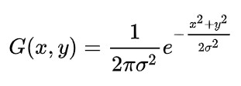
σ is the standard deviation of the Gaussian distribution blurred image is B(x,y)

B(x,y)=I(x,y)G(x,y)

We use deconvolution technique, like inverse filtering and Wiener deconvolution, to retrieve I(x,y).

1.5.3. Out-of-Focus Blur

Out-of-focus blur occurs dur to improper or incorrect focusing of the camera. It mostly occurs due to depth-of-field limitations. It appears as a softening of edges and details, particularly for object located at different distance from the lens. Resolving this type of blur requires identifying the regions with the strongest blur and applying algorithms to sharpen the edges. It can be represented as
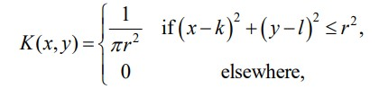

1.5.4. Radial Blur

Occurs due to zooming during exposure, which leads to a blur effect from a central point. To restore the image, we must find the center of the blur and reverse the radial spread, it requires complex algorithms for this process.

1.5.5. Atmospheric Blur (or Haze Blur)

It is occurred due to presence of particles like dust, fog, or mist between the camera and the object to be captured. This blur results in softened appearance, reducing contrast and details. As it requires dehazing techniques to enhance contrast and reduce the effect of particles by estimating depth information, it is complex to restore the image’s sharpness and color fidelity.

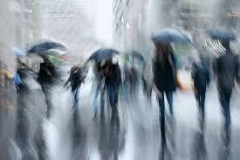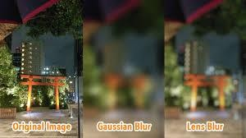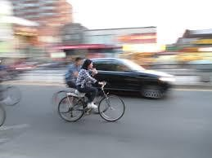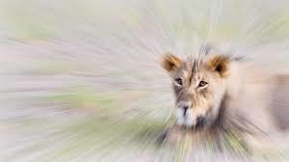
Fig 1.5.5.,Blur Types

SUMMING UP

As it restores the sharpness and clarity to blurred images, image deblurring is crucial for image processing and computer vision activities including autonomous vehicles, surveillance, object recognition, and medical imaging. Although deblurring has greatly improved with recent developments in computing power and algorithm development, research is still being conducted to develop faster, more reliable, and more broadly applicable techniques for practical applications. The Super Resolution Network (SRN) generator and the PatchGAN discriminator are combined in this project's GAN-based framework. The discriminator works on image patches to concentrate on texture and edges, guaranteeing high-quality deblurring results, while the SRN employs up sampling and down sampling layers to maintain details and minimize artifacts. With scalability for upcoming tasks in image restoration and degradation handling, the hybrid GAN-SRN model is made to minimize model complexity and produce clear, realistic images in realworld scenarios. This makes it appropriate for applications such as surveillance, medical imaging, and autonomous driving.

Chapter 2

Literature Review

2.1. LITERATURE GAPS

The GAN-based image deblurring has diverse approaches, each for different and unique challenges and pushing the boundaries of image restoration. Some of the limitations are worked out using these models. Many GAN-based models, such as DeblurDCTGAN and MBD-GAN, focuses on high computational demands, which makes real-time processing difficult and acquiring greater computational resources, which makes the utilization of their ability difficult in real world scenarios, especially on mobile or low-resource platforms. Approaches like EGAN, HFAR-GAN, and edge-heuristic multi-scale GANs are perfect for preserving textures and edges but has a drawback with non-uniform blur or diverse types of blur in real-world images. The efficiency on edgebased or high-frequency attention mechanisms even though effective in most scenarios, which can sometimes lead to reduced deblurring performance in datasets that has multiple types of blurs present in the same image. And also, the integration of components like inception blocks, DenseNet, or attention modules, increases model complexity, which makes the implementation and debugging difficult.

Most of the models that are present lack flexibility in adapting to real-world variations and extreme blur conditions. In case of models like SRN which employs recurrent modules to address multi-scale blur, also can struggle with intense blur scene changes. Models like DeblurGAN-v2 and the modified GAN by Xiaonan Zhang et al. works on improving processing speed and efficiency but requires lot more adaptation for complex, mixed degradations or real-time video deblurring. Several models depend mostly on large and diverse datasets for effective training of the model, with limited generalization on smaller datasets or synthetic images, such as in the case of cGAN for fingerphoto deblurring.

2.2. SURVEY PAPERS

Hiroki Tomosada, Takahiro Kudo, Takanori Fujisawa, and Masaaki Ikehara introduced "DeblurDCTGAN"[1]. This GAN-based approach utilizes DCT (Discrete Cosine Transform) loss to enhance the quality of deblurred images while reducing computational time. DCT loss aids in preserving texture details. The GAN component ensures that the deblurred images retain the intricate details of the original image. DeblurDCTGAN offers a faster computational speed compared to other methods. However, it requires substantial computational resources and may struggle with certain datasets like GoPro.

Li Song and Edmund Y. Lam proposed MBD-GAN[2]. This innovative approach integrates imaging models with deep learning techniques, leveraging a generative adversarial network (GAN). The GAN comprises a generator, tasked with producing deblurred images, and a discriminator, evaluating the accuracy of these images compared to the original. By combining prior knowledge from both domains, MBD-GAN enhances image estimation. The GAN component further improves accuracy. This framework is optimized for robustness. However, the integration of imaging models and deep learning can be complex, and the training process can be computationally intensive. Additionally, the model's performance is highly dependent on the training dataset, necessitating a large and diverse dataset.

Shuai Zheng, Zhenfeng Zhu, Jian Cheng, Yandong Guo, and Yao Zhao proposed an edge heuristic multi-scale generative adversarial network (GAN) for non-uniform blind deblurring[3]. This approach utilizes a coarse-to-fine scheme and a hierarchical content loss function to effectively restore clear images. The end-to-end training simplifies implementation, and the focus on edges ensures effective information preservation. The GAN component guarantees realistic deblurred images, and the edge heuristic approach effectively handles non-uniform blur. However, the method can be computationally expensive and time-consuming. Inaccurate edge detection can negatively impact deblurring performance, and regular fine-tuning may be necessary for different types of blur.

Ze-Ming Chen and Long-Wen Chang proposed a novel approach to improve the DeblurGAN generator for blind motion deblurring[4]. They introduced a combined inception block, residual block, and dense block architecture to effectively extract features from the blurry image. The use of DenseNet helps prevent overfitting. The adversarial loss component further enhances image quality. This model demonstrates effectiveness in blind motion deblurring tasks. However, it comes with high computational cost and complexity. A large dataset is required for training, and the combination of blocks can make debugging and implementation more challenging.

Xiaonan Zhang, Yang Lv, Yunjie Li, Yu Liu, and Pengcheng Luo proposed a modified image processing method for deblurring using GAN networks[5]. Their approach involves two separate processing paths for the input image, followed by feature extraction and GAN-based training. The dual-path architecture enhances feature extraction efficiency, and the method does not require prior knowledge. However, it suffers from high computational cost and time complexity. Additionally, the model may be prone to overfitting.

Amol S. Joshi, Ali Dabouei, Jeremy Dawson, and Nasser M. Nasrabadi introduced a method combining a conditional generative adversarial network (cGAN) with a guidedattention mechanism for fingerphoto deblurring[6]. This multi-stage framework demonstrates high effectiveness in challenging scenarios and contributes to fingerprint privacy. However, it is computationally intensive and complex, heavily reliant on synthetic data, and requires high-performance hardware.

Yungang Zhang, Yu Xiang, and Lei Bai proposed a Generative Adversarial Network (GAN) for deblurring remote sensing images[7]. Their approach utilized GANs to effectively deblur satellite images. The method does not require prior knowledge of the blur type or other image characteristics. However, the model is computationally complex, requiring significant processing power.

Qing Qi, Jichang Guo, and Weipei Jin proposed EGAN[8]. This method utilizes a generative adversarial network (GAN) framework incorporating an edge adversarial mechanism and a partial weight sharing network. EGAN employs edge-based segmentation to effectively handle non-uniform blur and ensure minimal information loss. However, the model suffers from high computational complexity. Additionally, the edge-based adversarial mechanism helps the model focus on preserving edge information, which is crucial for high-quality deblurring, while the partial weight sharing technique allows the network to share weights between different parts of the architecture, improving efficiency and potentially reducing overfitting.

Jitong Zhang, Guangmang Cui, Jufeng Zhao, and Ying Chen proposed a High-Frequency Attention Residual GAN (HFAR-GAN) for blind motion deblurring[9]. The HFAR module, consisting of a Fourier Channel Attention (FCA) module and an Edge Spatial Attention (ESA) module, effectively processes and deblurs images. This approach ensures that important details are not ignored or omitted. However, the HFAR-GAN model suffers from high computational complexity.

Xin Tao, Hongyun Gao, Xiaoyong Shen, Jue Wang, and Jiaya Jia proposed a ScaleRecurrent Network (SRN) for deep image deblurring[10]. SRN shares network weights across scales to significantly reduce training difficulty and introduce stability benefits. This approach significantly reduces the number of trainable parameters and incorporates recurrent modules to capture useful information from previous states. However, SRN suffers from high computational complexity, difficulty in handling extreme blur, and limited flexibility.

Orest Kupyn, Tetiana Martyniuk, Junru Wu, and Zhangyang Wang introduced DeblurGAN-v2[11]. This model incorporates a Feature Pyramid Network (FPN) into the generator of the original DeblurGAN, significantly improving deblurring speed and quality. DeblurGAN-v2 is 10-100 times faster than previous methods while achieving near state-of-the-art results. It particularly requires improvement for real-time video enhancement and handling mixed degradations.

2.3. MODEL ADVANTAGE

The proposed model utilizes the strengths of GAN and SRN, focusing on improving computational efficiency while maintaining robust deblurring performance. By utilization of advanced SRN generator with simplified residual and attention blocks, the model efficiently obtains and stores the fine details at the time of minimizing computational complexity. And also, the model is designed to be more reliable towards non-uniform and diverse types of blur through multi-scale training techniques, which makes it better across real-world scenarios consisting of diverse types of blur. The utilization of PatchGAN discriminator helps the model to keep track on local textures without overloading computational resources, at the same time making it suitable and efficient for mobile or low-resource platforms. It is a balanced approach that makes the model suitable for realworld applications, from mobile devices to autonomous systems,and utilization of the model resilient across the limitation of computation and generalization.

Chapter 3

Proposed Methodology

3.1. GAN ARCHITECTURE

GAN is used as the main pillar for the project of image deblurring. It is an enhanced machine learning model which consists of two major components namely the generator and discriminator. Both of the components work together in an adversarial network. These components play different roles but complementary role to obtaining high quality of image deblurring.

The generator works in a way to create more realistic deblurred image compared to the original blurred image. The generator keeps on learning to minimize the difference of the generated image from the original image. Its major focus is to generate an image that is more realistic to original image. In which the generated image manipulates the discriminator that the image is original. At the same time, the discriminator distinguishes the real and the images generated by the generator like a judge. It helps the generator to improve the quality of the image generated until the image generated manipulates the discriminator as it is the original image.

The adversarial interaction between them motivate the generator to produce more realistic and sharp images. As the generator improves based on the feedback from the discriminator , it makes the differentiation of the original image from the generated image difficult for the discriminator. This adversarial training process results in generator making highly realistic deblurred image.

GAN is mostly utilized in the process of image restoration and image synthesis. In case of image deblurring it not only helps in reducing the blur but also paves way to preserving the details in the image. Which makes it a powerful tool to deblur complex challenges compared to traditional method which often struggles to deblur. The architecture of GAN is as follows,
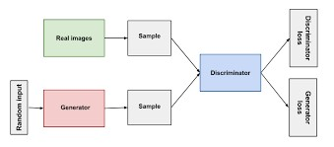

Fig 3.1., GAN Architecture

As the architecture visualizes, the real image is sent as sample and the generator generates an image from some random input and the generated image is sent into the discriminator and the discriminator classifies the difference in the images and classifies whether the image is original image or fake image. If the discriminator classifies the image correctly then it is generator loss and if the discriminator doesn’t classify then it is discriminator loss.

3.2. SRN GENERATOR

Because of the ability of super resolution network to reconstruct the details present in the image from the degraded image, it is used as the generator. It consists of a series of residual blocks, which conserve important details present in the blurred image. These residual connections help improve the stability and sustain the images details by the help of down sampling and up sampling layers. It consists of three stages in which initial convolutional Layer extracts the features of the image, then do sampling with residual block in which we reduce the spatial dimension and add the residual connection for information preservation. Then finally comes the up-sampling Stage in which we enhance the spatial resolution to recreate the sharp image.

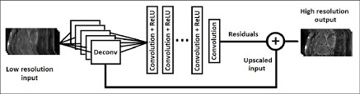

Fig 3.2., SRN Architecture

The first stage is initial convolution layer, it applies a series of filters on the image to make the network be able to capture low level details like the edges, texture for accurate reconstruction of the blur image. Because of it, the important features are identified and the features are managed in further layers in order to store it. This helps in identification of subtle features that plays a major role in reconstruction process.

The next stage is down sampling with residual blocks, down sampling is the process of reducing the images spatial dimension on the increment of the number of feature channels. It makes the model to identify the image information that are important like the structure and patterns in low-dimensional space. Residual blocks have the ability of skip connections, which is the process in which there is a presence of shortcut between the input and to bypass one or more layers and get added in the output. This helps in retaining the fine details present in image during the down sampling process.

The last stage is up sampling, here the network restores the images spatial dimension to the original size. It is the opposite process of downsampling. It aims to create clear and high-resolution version of the original blurred image. It uses techniques like nearest neighbor interpolation , convolution and pixel shuffle to increase spatial dimension. As the up sampling takes place, the network gets to know more on how to refine the edges and sharpen the blur image.

3.3. PATCHGAN DISCRMINATOR

The discriminator is used to evaluate or compare the detail from the image generated to the original blurred image. The Patch Gan is used in order to focus on small patches rather than looking at the whole image. It allows it to focus and evaluate the local textures and structural accuracy of the image generated. The traditional discriminators work on the whole image whereas the PatchGAN works on patches which makes it effective for tasks like deblurring as it looks into the local textures and fine details that make the difference between the original blurred image and the generated image. It mostly divides into small pixel values as 70*70. And then evaluates the realness of the generated image. It makes sure the generated image is sharp and has details even in fine grained level. It helps to maintain the consistency around the image preserving the key features. It consists of a sequence of Conv2D layers paired with LeakeyReLU activation. The layers utilize the convolutional filters to extract the features across each of the patches of the image. The first occurring features capture basic edges and contours while the rest focus on complex textures and patterns. Because of working on Patch, the details like the hair, skin texture all are isolated to preserve the information with the focus to produce a sharp image. Which helps in the evaluation of the image for the texture and accuracy of the reconstructed image. LeakyReLU activation helps in the learning of features and the characteristics along each patch. The usage of this helps in a way by making all the neurons to be active and learn throughout the training process. It also helps in identification of sensitive textures and contrast changes that are important for deblurring.

These help to maintain the consistency of the image generated by the generator by evaluating in patches and by assigning a score for realness across each of the patches, it paves way to identify if the generator to produce image that is overall sharp but lacking details in few regions. It also helps to concentrate more on the features if it recognizes the presence of fine textures and features that are important to be clear and realistic. Because of it is able to give efficient feedback on which particular region needs to be more focused on generation of the image by the generator.

Firstly, the image as soon as it is imported form the generator , it is divided into small patches of each 70&70 pixels. Then each patch is processed by Conv2D layer which extracts the image information in the form of features from low level to high level. Then LeakyReLU activation is applied to each of the convolution layer to introduce nonlinearity which helps the discriminator to learn different scenarios. Then the score is assigned to each of the patches and then they are aggregated to produce overall score. Based on the score the feedback is provided to the generator to focus on the regions that needs development and improvement. This process occurs iteratively until the generator produces image that is indifferentiable by the discriminator from the original image.

Chapter 4

Dataset

4.1. GOPRO DATASET

The GoPro dataset is majorly used for image deblurring because of the quality of the blur and also it consists of sharp images that were captured in the real word. It consists of two pairs of images data one for validation and the other for training in which there are blur and sharp images present. Go-pro dataset consisting about a total of 3000 images It consists of thousands of images across different scenarios in by different types of blur. The images are resized to a fixed dimension of 265*256 pixels in order to reduce the dimensionality. Then the pixel values ae normalized which helps to converge the model faster.

4.2. DATA IMPORTATION AND SPLITTING

For effective utilization of the data present both the validation and the training data are imported. The training set is used to optimize and the test set is to evaluate the generalization. In case of different real-world scenarios techniques like random cropping, rotation, horizontal flips, and intensity scaling can be done as per requirement. These transformations help in modal adaptability to different types of real-world scenarios. After importing the normalization of the image in order to do the further processing smoothly. And also, the image is resized to fixed pixel value and then into 8 batches for better processing of the images. As preprocessing steps, we do the process of image resizing and pixel normalization. We resize the image on input to 256*256-pixel values and around 8 batches of the total images present in the training data. Then we normalize the pixel values to do the further processing on the blur image to obtain deblurred image.

Chapter 5

Implementation

5.1. MODEL DESIGN

In this model we use three components namely SRN Generator, PatchGAN discriminator and then finally the integration of the generator and discriminator is done by GAN. Each component in the model plays a vital role in the process of image deblurring.

5.1.1. SRN Generator

The model consists of three components the SRN generator,
PatchGAN discriminator and the GAN model. The SRN Generator is used to
enhance the resolution of blur images and create unblur images by learning the residual information present in the blur images. It consists of convolutional layers, residual blocks, and up sampling layers. The residual blocks focus on capturing the derails present in the blur image and each block present consist of Conv2D layers with ReLU activation function batch normalization and skip connections to preserve the important features. In order to accurately reconstruct the blurred image, the first stage, known as the initial convolution layer, applies a number of filters to the image in order to capture low-level information like edges and textures. This helps the network find minor elements that are essential for the reconstruction process by enabling it to recognize significant features that are subsequently maintained in additional layers for storage. The next step is down sampling with residual blocks, which increases the number of feature channels while decreasing the spatial dimension of the image. In a lower-dimensional space, this allows the model to concentrate on key picture information, such as structure and patterns. By establishing shortcuts between input and output, residual blocks preserve small features in the image while down sampling. Up sampling is the last step, which reverses the down sampling process and returns the image's spatial dimension to its initial size. By increasing spatial dimensions through methods like convolution, pixel shuffle, and nearest neighbour interpolation, the network is able to sharpen the fuzzy image and enhance edges.

5.1.2. PatchGAN Discriminator

The PatchGAN discriminator focuses on capturing high frequency details using Conv2D and LeakyReLU activation. It operates in patches to evaluate the realism. It consists of Conv2D layers with increasing filters and ends with sigmoid activation layer to output possibilities of the real and fake image patches. The image is split into tiny portions of 70 * 70 pixels as soon as it is loaded from the generator. The Conv2D layer then processes each patch, extracting picture information in the form of low-level to high-level features. Next, each convolution layer receives LeakyReLU activation, which adds non-linearity and aids in the discriminator's learning of various contexts. Following that, each patch is given a score, which is then combined to create the final score. The generator receives feedback based on the score, which helps them concentrate on the areas that require improvement and development. This procedure is repeated until the generator creates an image that the discriminator cannot distinguish from the real image.

5.1.3. GAN

The GAN model combines both the generator and discriminator components. It sends the blurred images in the SRN generator which then produces a deblurred output. That is then evaluated by the discriminator. The feedback from the discriminator are taken as input and are used to training the generated to produce more effective output of deblurred patches from the SRN generator. By continuously learning to reduce the difference from the original image, the generator aims to produce more realistic deblurred photos while concentrating on producing more realistic images overall. The discriminator is tricked into believing the created image to be the original. By separating genuine images from those produced by the generator, the discriminator serves as a judge in the meantime, assisting the generator in enhancing image quality until the created image deceives the discriminator. The generator is motivated to create sharper and more realistic images by their adversarial interaction. The discriminator finds it more difficult to distinguish between the created and original photos as the generator gets better based on feedback from the discriminator, producing deblurred images that are incredibly real.

5.2. LOSS FUNCTIONS

There are different types of loss functions utilizes in the model for the generator and discriminator

5.2.1. Mean Squared Error(MSE)

Mean Squared Error is the measure of error in statistical models by using the average squared difference between the observed and the predicted values. It is a common metric used in statistical models. It can be represented as
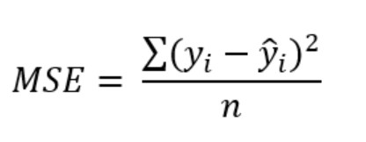
In which , y_{i} is the i^{th} observed value. ŷ_{i} is the corresponding predicted value. n is the number of observations.
It is used to help the generator to create output images similar to the sharp images by penalizing the pixel difference between the generated and the original image. It helps to minimize reconstruction error.

5.2.2. Binary Cross Entropy Loss

Binary cross entropy is a loss function which is used to measure the performance of classification. It can have outcomes as 0 and 1.It can be represented as
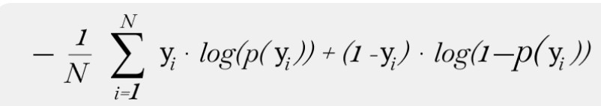
The discriminator and Gan use binary cross entropy loss in which generator uses it to distinguish between the generated output from the generator and the real sharp image. In case of GAN makes the generator to develop more real images with the aim of generating images not identifiable by the discriminator as fake image.

5.3. OPTIMIZER AND LEARNING RATE

5.3.1. Adam Optimizer

Adaptive Moment Estimation is the iterative optimization algorithm which is used to minimize the loss function during training. We can also say that it is the combination of RMSprop and Stochastic Gradient Descent with momentum. It is selected for its adaptive learning rate capabilities which makes it more compatible in working with GAN. It helps to do the convergence smoother making this reach optimal weight efficiently.

5.3.2. Learning Rate

It helps in reducing the learning rate after a number of epochs. In this project the learning rate is reduced after 50 epochs making it stable during the convergence. At the same time avoids overshooting the optimal weight and improving the performance.

5.4. TRAINING PROCESS:

5.4.1. Training Loops

In each of the epoch, random batch of blurred images and the sharp parts are selected and they are fed into the training loop in which the generator and the discriminator is updated. The discriminator is updated in a way that it is trained with both the real and the fake images and it learns to distinguish between the real and fake by minimizing the cross-entropy loss and updating the weights regularly. As soon as the discriminator is updated, the generator is trained to generate images that can manipulate the discriminator. With the help of GAN , the generated modifies the weight to minimize the MSE loss to make more realistic images.

5.4.2. Epoch count and Batch size

We have set the training process to continue for 500 epochs with a batch size of 8 which can also be modified as per preference .The high epoch count makes sure the generator learns more about the details in the image at the mean time batch size is helpful in balancing the training sped and convergence of the model.

5.5. EVALUATION METRICS

5.5.1. Peak Signal to noise Ratio

It is used to quantify the ratio of signal to noise in the generated output image. It compares the similarity between the generated image and the original image. The better the PSNR value better the deblurred image having less artifacts.

5.5.2. Structural Similarity Index Measure

It measures the structural similarity between the original and generated image based on luminance, contrast and structure. It occurs between -1 to +1, meaning the higher has much similarity. So, in case of deblurring the higher is better indicating the image preserves the structure and textures present in the original image.

Chapter 6

Challenges and Solutions

6.1. MODEL TRAINING AND CHALLENGES

6.1.1. Computational Constraints

The development of GAN is computationally complex because of the presence of both the generator and discriminator .The SRN complexity also adds resource demands while handling high resolution images like in the dataset used. Limited computational resources also restrict the ability to fine tune models. To solve this issue the number of epochs were adjusted and reduced. The hybrid models training epochs were limited to 100 from initial target of 10000 .The batch sizes were tunes in order to balance the memory usage and model accuracy. By the use of GPU support ,retaining speed was increased.

6.1.2. Overfitting

It is one of the common issues in GAN training in which , the model becomes more favorable on training dataset and faces problem to new images. Data augmentation was used to provide diversity in data by utilization of diverse transformations in the training images. Addition to that, regularization technique of dropout layer in the SRN and the batch normalization were introduces and utilized in the network architecture to prevent overfitting.

6.1.3. Stability

GAN are extremely difficult to train because of the instability in the generator and discriminator dynamic. It is causes collapse in which the generator produces less variation in images, vanish of gradients leading to stall the process of training. In order to overcome this, parameters like learning rate, batch size and optimizer were tuned carefully. Learning rate scheduler war introduced to reduce the learning rate which helps in avoiding jumps in model. The Adam optimizer was used to stabilize training. The PatchGAN discriminator was used to improve stability because of focusing on patch level rather than the whole image.

6.2. REAL WORLD VARIATIONS

6.2.1. Model Generalization

In order to maintain various types of blurs in real world scenarios caused like the motion blur, the training data were modified and adjusted to include various types of blur. Data Augmentation were also included to generate synthetic blur variations to face real world scenarios .It helped the model to inspect for various types of blur like motion blur and different lighting conditions.

6.2.2. Diverse types of blurs

Traditional methods lack the ability to deblur the different types of blurs present and make the computation more complex .The presence of different types of blurs in the single images made the model to deblur the image unrealistic and more complex. The utilization of residual blocks within the generator helped in enhancing the ability to obtain the presence of fine details present in the image. Because of which the model was able to focus on high frequency areas and leave the uniform areas making it adaptable to various types of blur. It helped to handle blurs more effectively.

Chapter 7

Result and Inference

The hybrid model incorporating Super Resolution Network (SRN) generator and a PatchGAN discriminator was developed to undergo image deblurring. The aim of this project was to develop a model which not only enhances the sharpness of deblurred images but also maintains computational efficiency and robustness which makes it suitable for real-world applications.

RESULTS:

7.1. REAL WORLD VARIATIONS

In order to test the performance of the hybrid model, several standard metrics, like Peak Signal-to-Noise Ratio (PSNR) and Structural Similarity Index Measure (SSIM)was used. Higher PSNR values indicate better closeness between the deblurred image and the original image, while SSIM is used measure the structural integrity of the image obtained. The model achieved a PSNR of [44.30db] and an SSIM of [0.8916] on the test image. Compared to traditional deblurring methods and other GAN-based models, the hybrid model demonstrated higher PSNR and SSIM values, indicating that our model provides a more faithful reconstruction of the original sharp image.

7.2. VISUAL QUALITY AND REALISM

The visualization results of hybrid model produced images with enhanced sharpness and reduced artifacts, effectively handling the diverse types of blur present in the GoPro dataset. By focusing on patches ,the PatchGAN discriminator helped the model to better capture local textures and fine details. This helped to improve the deblurring of edges and textures. The SRN generator, with its down sampling and up sampling layers helped to sustain image quality, as the residual connections helped to store key image details throughout the network’s layers.

7.3. COMPARISON WITH BASELINE MODELS

On comparing the hybrid model to traditional deblurring methods, such as Wiener filtering and blind deconvolution, the model showed superior results. Unlike traditional methods, which often struggle with complex blur patterns and result in over smoothing or loss of details, our model efficiently deblurred complex images by utilizing adversarial training and hierarchical feature extraction.

7.4. COMPUTATIONAL EFFICIENCY

The main objectives of this project were to balance model complexity while sustaining the performance. By using a hybrid model, it was possible to reduce the computational load without leaving back the image quality. The SRN generator’s for down sampling and up sampling, minimizing redundant computations at the same time maintaining important features in the image. This structure led to faster processing times compared to other deep learning-based methods. It is the main reason why the hybrid model can be utilized in real world scenarios.

INFERENCE:

PEAK SIGNAL-TO-NOISE RATIO (PSNR)
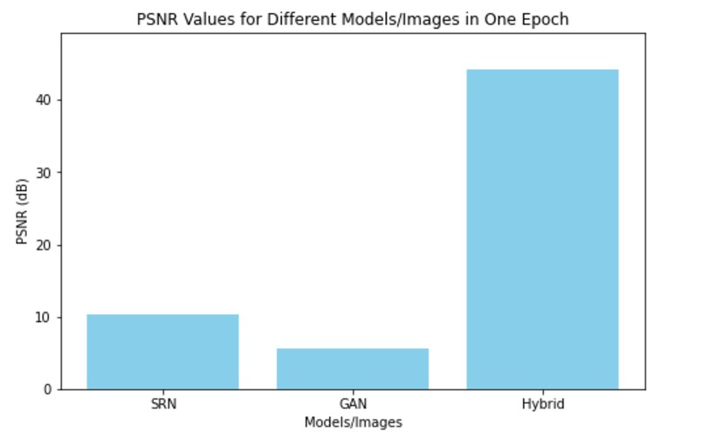

Fig 7.1, PSNR comparison

The Peak Signal-to-Noise Ratio (PSNR) is a metric used to measure the quality of a image, in image restoration tasks. It is calculated using the Mean Squared Error (MSE) between two images, the higher the better the image quality. PSNR is measured in decibels (dB)
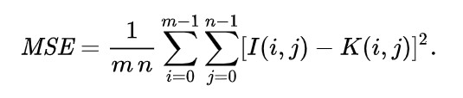
noise-free m×n monochrome image I noisy approximation K

The performance of the models in image deblurring were evaluated using PSNR (Peak Signal-to-Noise Ratio). The standalone models of SRN and GAN were comparesd with the hybrid model.The standalone SRN (Super-Resolution Network) model achieved a PSNR score of 10.28 dB, which is relatively low which makes the the output obtained to suboptimal or less image quality. The Standalone GAN focuses on the generation of more similar image that is the reason foe the less PSNR value of 5.53 dB which is worst. At the mean time, the hybrid model obtained a PSNR Score of 44.30 dB. This combination of the models in the hybrid model successfully helped by using SRN’s detailed reconstruction with GAN's ability to generate realistic details and finally producing images that are much closer to the ground truth and offering superior deblurring performance.

STRUCTURAL SIMILARITY INDEX MEASURE(SSIM)

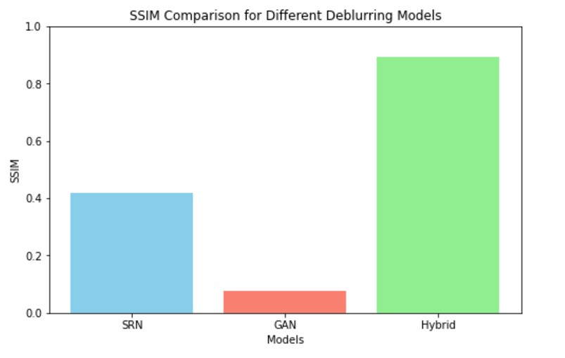

Fig 7.2, SSIM

SSIM is a measure of image similarity. It values closer to 1 indicating higher similarity to the reference (sharp) image, meaning better image quality for deblurring tasks.It evaluates how similar the deblurred image is to the original sharp image.It is calculated as
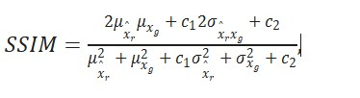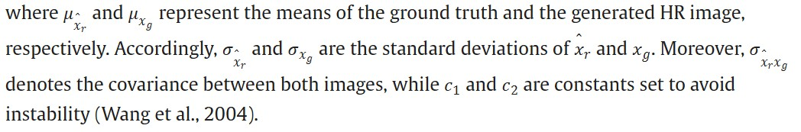

The Super-Resolution Network (SRN) achieved an SSIM of 0.4190, an moderate structural similarity with the original sharp image. Indicating, it struggles to restore fine structures, resulting in partial similarity. the Generative Adversarial Network (GAN) has a significantly lower SSIM of 0.0754, reflecting its difficulty in maintaining structural accuracy and producing images that are far from the original sharp image. This is because GAN are used for creating images that are more similar to the original image. With an SSIM of 0.8916, the hybrid model—which combines SRN and PatchGAN—performs remarkably well. This high value shows that the hybrid model effectively combines the realistic picture-creation capabilities of GAN with the detail restoration capabilities of SRN, resulting in a nearly flawless reconstruction of the crisp image. In deblurring tasks, the hybrid model is notable for maintaining both structure and realism.

Chapter 8

Conclusion

8.1. OUTCOME

The hybrid model obtained significant advancement in performance of deblurring compared to traditional models. The utilization of PatchGAN discriminator, tuned SRN generator with residual blocks and adjustments to enhance generalization played a vital role in this process. The model was able to identify various types of blurs and produce more clearer and more detailed output in real-world scenarios.

8.2. EFFICIENCY

The hybrid model was more effective in case or real-world scenarios of diverse type of blurs in addition with higher performance rather than convolutional methods or techniques of deblurring. The model was also trained to reduce the number of epochs without loss in quality of the image. The generator with the presence of residual blocks played a vital role in maintaining the quality of the image as well maintaining the features present in the image. In conclusion the hybrid model achieved favorable balance between computational efficiency and clarity of the image.

8.3. FUTURE APPLICATIONS

Because of the advancement in the technology used it makes the hybrid model to be utilized in multiple filed like surveillance, photography, medical imaging and automotive applications. The ability of the model to restore the deblurred images under dynamic and different conditions on the real-world scenarios it makes it more suitable and applicable for high time consuming and high precision demanding jobs.

Chapter 9

Future Works

9.1. IMPROVING MODEL ROBUSTNESS

In addition to recent word on this project of hybrid model , the model can be improved by focusing of different types of blurs and making the model robust to it. It can be achieved by incorporating more real-world datasets that has influence on various types of blurs. And also employing adversarial training technique to face multiple types of blur during the training. It helps the model to handle more unpredictable and complex realworld scenarios

9.2. EXPLORING EFFECTIVE AND EFFICIENT ARCHITECTURES

Alternative Architectures like transformer based and efficient Net based model can be used to improve the accuracy as well the computational efficiency for the deblurring process. Transfer learning can be used to skip some initial steps in case of initial boost and reducing the need for extensive training.

9.3. MODEL INTEGRATION

The expanse of the hybrid model on mobile devices make is more usable . Model quantization and pruning can be utilized to reduce the model size and computational demands. Which makes it more usable on devices that has limited processing power. This can lead to extensive use of the model for boarder accessibility and utilization of it in the real-world scenarios with the help of personal devices, surveillance cameras and so on.

9.4. REAL-TIME VIDEO PROCESSING

Improving the model to face video sequences and better deblurring. It focuses on accounting temporal coherence between frames to avoid flickering and to greatly smooth transitions. These enhancement makes the Hybrid model to be most suitable in fields like video surveillance, live streaming, and augmented reality in which real-time deblurring is crucial.

9.5. HYPERPARAMETER OPTIMIZATION

Optimization of hyperparameter is a time-consuming process. By the introduction of automated hyperparameter tuning methods like grid search or Bayesian optimization helps to enhance the model’s performance with least human assistance. It helps to identify multiple efficient parameter combinations to obtain the most suitable outcome.

Appendix 1

1 Data Importation and Preprocessing

def load_images(dataset_path, img_size=(256, 256)):
blur_images = [] sharp_images = [] blur_path = os.path.join(dataset_path, "train", "input/input") sharp_path = os.path.join(dataset_path, "train", "target/target")

for img in os.listdir(blur_path): blur_img = cv2.imread(os.path.join(blur_path, img)) if blur_img is None:
continue
blur_img = cv2.resize(blur_img, img_size).astype(np.float32) / 255.0 blur_images.append(blur_img)

sharp_img = cv2.imread(os.path.join(sharp_path, img)) if sharp_img is None:
continue
sharp_img = cv2.resize(sharp_img, img_size).astype(np.float32) / 255.0 sharp_images.append(sharp_img)

return np.array(blur_images), np.array(sharp_images)

dataset_path = r'D:/deblur/GoPro'
blur_images, sharp_images = load_images(dataset_path)

2 SRN generator using Residual block

#Residual Block for the Generator def residual_block(x, filters):
skip = x
x = Conv2D(filters, kernel_size=3, strides=1, padding='same')(x) x = BatchNormalization()(x) x = Activation('relu')(x)
x = Conv2D(filters, kernel_size=3, strides=1, padding='same')(x) x = BatchNormalization()(x) x = Add()([x, skip]) # Residual connection return x

# SRN Generator with Residual Blocks def srn_generator(input_shape=(256, 256, 3)): inputs = Input(shape=input_shape)
x = Conv2D(64, kernel_size=5, strides=1, padding='same')(inputs) x = BatchNormalization()(x)
x = Activation('relu')(x)

# Downsampling and Residual Blocks for _ in range(2):
x = Conv2D(128, kernel_size=3, strides=2, padding='same')(x) x = BatchNormalization()(x) x = Activation('relu')(x)
x = residual_block(x, 128)

# Upsampling for _ in range(2):
x = Conv2DTranspose(128, kernel_size=3, strides=2, padding='same')(x) x = BatchNormalization()(x)
x = Activation('relu')(x)

outputs = Conv2D(3, kernel_size=5, strides=1, padding='same', activation='tanh')(x) return Model(inputs, outputs)

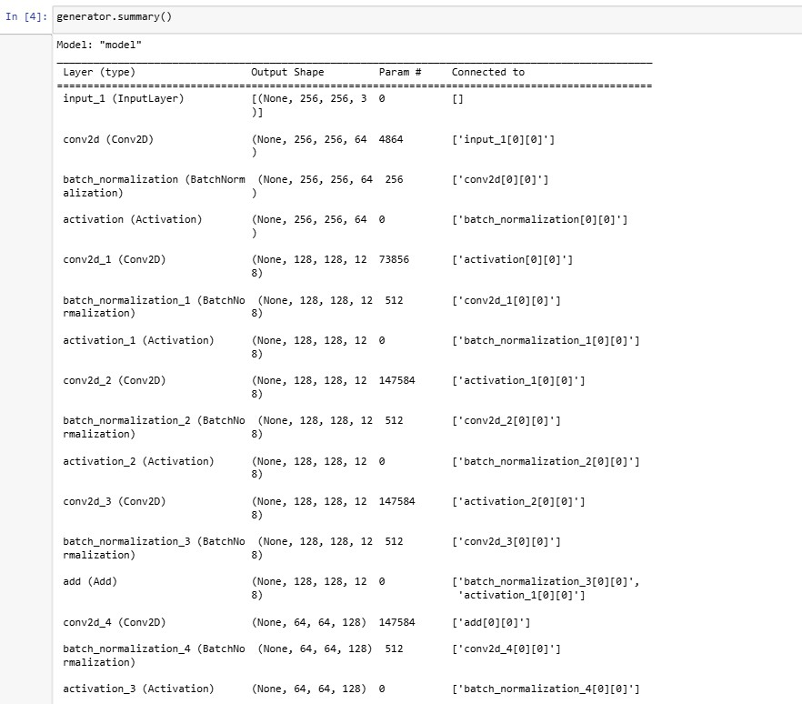
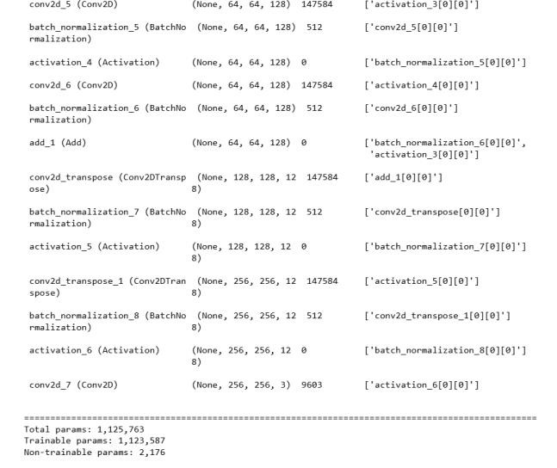

3 PatchGAN discriminator

# PatchGAN Discriminator def build_patchgan_discriminator(input_shape=(256, 256, 3)): inputs = Input(shape=input_shape)
x = Conv2D(64, kernel_size=4, strides=2, padding='same')(inputs) x = LeakyReLU(0.2)(x)

for _ in range(3):
x = Conv2D(128, kernel_size=4, strides=2, padding='same')(x) x = BatchNormalization()(x)
x = LeakyReLU(0.2)(x)

outputs = Conv2D(1, kernel_size=4, strides=1, padding='same', activation='sigmoid')(x)
return Model(inputs, outputs)

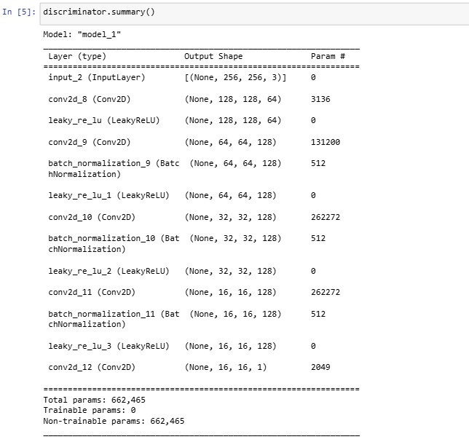

4 GAN Integration

# GAN Integration def build_gan(generator, discriminator): discriminator.trainable = False gan_input = Input(shape=(256, 256, 3)) deblurred_image = generator(gan_input) gan_output = discriminator(deblurred_image)
return Model(gan_input, gan_output)

# Learning rate scheduler def lr_scheduler(epoch, lr): if epoch > 50: return lr * 0.5
return lr

# Model initialization generator = srn_generator() discriminator = build_patchgan_discriminator() gan = build_gan(generator, discriminator)
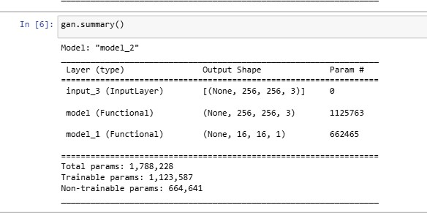

5 Model Training

# Training Parameters epochs = 501 batch_size = 8 real_label = np.ones((batch_size, 16, 16, 1))
fake_label = np.zeros((batch_size, 16, 16, 1))

for epoch in range(epochs): idx = np.random.randint(0, blur_images.shape[0], batch_size) real_imgs = sharp_images[idx]
blur_imgs = blur_images[idx]

fake_imgs = generator.predict(blur_imgs)

# Training Discriminator d_loss_real = discriminator.train_on_batch(real_imgs, real_label) d_loss_fake = discriminator.train_on_batch(fake_imgs, fake_label) d_loss = 0.5 * np.add(d_loss_real, d_loss_fake)

# Training Generator
g_loss = gan.train_on_batch(blur_imgs, real_label)

if epoch % 10 == 0: print(f"{epoch} [D loss: {d_loss}] [G loss: {g_loss}]")

# Storing generator weights
generator.save_weights('generator_weights.h5')

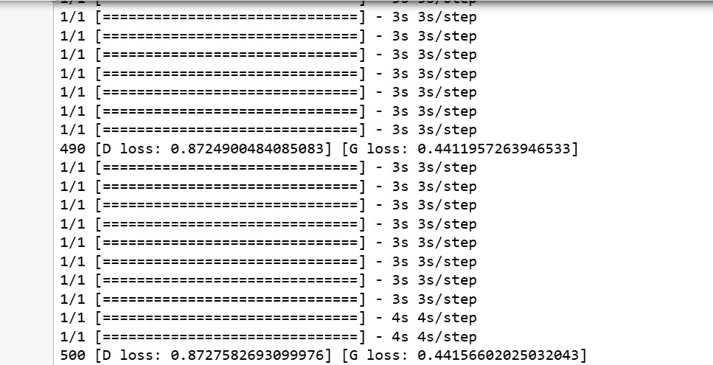

6 Model Compilation

#Compiling models opt = Adam(learning_rate=0.0002, beta_1=0.5) generator.compile(loss='mse', optimizer=opt) discriminator.compile(loss='binary_crossentropy', optimizer=opt) gan.compile(loss='binary_crossentropy', optimizer=opt)

7 Standalone SRN

# SRN model for deblurring def srn_model(input_shape=(256, 256, 3)): def res_block(x, filters, kernel_size=3): res = Conv2D(filters, kernel_size=kernel_size, padding='same')(x) res = LeakyReLU(alpha=0.2)(res) res = BatchNormalization()(res)
res = Conv2D(filters, kernel_size=kernel_size, padding='same')(res) res = BatchNormalization()(res) return Add()([x, res])

inputs = Input(shape=input_shape)

# Encoder
x = Conv2D(64, kernel_size=3, strides=2, padding='same')(inputs) x = LeakyReLU(alpha=0.2)(x)
x = BatchNormalization()(x)

# Residual blocks for _ in range(4): x = res_block(x, 64)

# Decoder x = UpSampling2D()(x)
x = Conv2D(64, kernel_size=3, padding='same')(x) x = LeakyReLU(alpha=0.2)(x)
x = BatchNormalization()(x)

outputs = Conv2D(3, kernel_size=3, padding='same', activation='tanh')(x)

model = Model(inputs, outputs)
return model

# Training def train_srn(model, blur_images, sharp_images, epochs=100, batch_size=8):
model.compile(optimizer=Adam(learning_rate=0.0002), loss='mse') for epoch in range(epochs): idx = np.random.randint(0, blur_images.shape[0], batch_size) blur_batch = blur_images[idx]
sharp_batch = sharp_images[idx]

loss = model.train_on_batch(blur_batch, sharp_batch) if epoch % 10 == 0: print(f"Epoch {epoch}/{epochs}, Loss: {loss:.4f}")

model.save('srn_deblur_model.h5')
print("Model saved as 'srn_deblur_model.h5'.")

# Deblurring function for testing def deblur_image(model_path, input_path, output_path, img_size=(256, 256)): model = srn_model(input_shape=(img_size[0], img_size[1], 3)) model.load_weights(model_path)

# Load and preprocess input image blur_img = cv2.imread(input_path) if blur_img is None:
print("Image not found.")
return

blur_img_resized = cv2.resize(blur_img, img_size).astype(np.float32) / 255.0 blur_img_batch = np.expand_dims(blur_img_resized, axis=0)

# Generate deblurred image
deblurred_img = model.predict(blur_img_batch)[0]
deblurred_img = np.clip(deblurred_img * 255, 0, 255).astype(np.uint8)

# Save and display results cv2.imwrite(output_path, deblurred_img)
print(f"Deblurred image saved at {output_path}")

# Calculate PSNR and SSIM psnr_value = psnr(blur_img_resized, deblurred_img / 255.0, data_range=1.0) ssim_value = ssim(blur_img_resized, deblurred_img / 255.0, channel_axis=-1, data_range=1.0)
print(f"PSNR: {psnr_value:.2f}, SSIM: {ssim_value:.4f}")

# Display original and deblurred images
plt.figure(figsize=(10, 5)) plt.subplot(1, 2, 1)
plt.title("Original Blurry Image")
plt.imshow(cv2.cvtColor(blur_img, cv2.COLOR_BGR2RGB)) plt.axis('off')

plt.subplot(1, 2, 2) plt.title("Deblurred Image")
plt.imshow(cv2.cvtColor(deblurred_img, cv2.COLOR_BGR2RGB)) plt.axis('off')
plt.show()

Testing
# Main code execution
dataset_path = r"D:\deblur\GoPro" # Replace with your dataset path blur_images, sharp_images = load_data(dataset_path)

# Initialize and train the SRN model srn = srn_model()
train_srn(srn, blur_images, sharp_images)

# Deblur a test image
input_image_path = r"D:\deblur\GoPro\train\input\input\GOPR0372_07_00-000049.png"
# Replace with your input image path
output_image_path = r"D:\clg\MINI Project\deblurred_image.png" # Replace with your output image path
deblur_image('srn_deblur_model.h5', input_image_path, output_image_path)

7 Standalone GAN

##GAN
def build_generator(input_shape=(256, 256, 3)):
def res_block(x, filters, kernel_size=3):
res = Conv2D(filters, kernel_size=kernel_size, padding='same')(x)
res = LeakyReLU(alpha=0.2)(res)
res = BatchNormalization()(res)
res = Conv2D(filters, kernel_size=kernel_size, padding='same')(res) res = BatchNormalization()(res) return Add()([x, res])

inputs = Input(shape=input_shape)

# Encoder
x = Conv2D(64, kernel_size=3, strides=2, padding='same')(inputs) x = LeakyReLU(alpha=0.2)(x)
x = BatchNormalization()(x)

# Residual blocks for _ in range(4):
x = res_block(x, 64)

# Decoder x = UpSampling2D()(x)
x = Conv2D(64, kernel_size=3, padding='same')(x) x = LeakyReLU(alpha=0.2)(x)
x = BatchNormalization()(x)

outputs = Conv2D(3, kernel_size=3, padding='same', activation='tanh')(x)

model = Model(inputs, outputs)
return model

def build_discriminator(input_shape=(256, 256, 3)): inputs = Input(shape=input_shape)

x = Conv2D(64, kernel_size=3, strides=2, padding='same')(inputs) x = LeakyReLU(alpha=0.2)(x)

x = Conv2D(128, kernel_size=3, strides=2, padding='same')(x) x = LeakyReLU(alpha=0.2)(x)
x = BatchNormalization()(x)

x = Conv2D(256, kernel_size=3, strides=2, padding='same')(x) x = LeakyReLU(alpha=0.2)(x)
x = BatchNormalization()(x)

x = Flatten()(x)
x = Dense(1, activation='sigmoid')(x)

model = Model(inputs, x)
return model

def build_gan(generator, discriminator): discriminator.trainable = False gan_input = Input(shape=(256, 256, 3)) generated_image = generator(gan_input) gan_output = discriminator(generated_image) gan = Model(gan_input, gan_output)
return gan

Training def train_gan(generator, discriminator, gan, blur_images, sharp_images, epochs=100, batch_size=8): real_label = np.ones((batch_size, 1))
fake_label = np.zeros((batch_size, 1))

for epoch in range(epochs): idx = np.random.randint(0, blur_images.shape[0], batch_size) blur_batch = blur_images[idx]
sharp_batch = sharp_images[idx]

# Generate fake images
fake_images = generator.predict(blur_batch)

# Train Discriminator d_loss_real = discriminator.train_on_batch(sharp_batch, real_label) d_loss_fake = discriminator.train_on_batch(fake_images, fake_label) d_loss = 0.5 * np.add(d_loss_real, d_loss_fake)

# Train Generator
g_loss = gan.train_on_batch(blur_batch, real_label)

if epoch % 10 == 0: print(f"Epoch {epoch}/{epochs} - D Loss: {d_loss:.4f}, G Loss: {g_loss:.4f}")

generator.save('gan_generator.h5')
print("Generator model saved as 'gan_generator.h5'.")

Testing def deblur_image(model_path, input_path, output_path, img_size=(256, 256)): generator = build_generator(input_shape=(img_size[0], img_size[1], 3)) generator.load_weights(model_path)

blur_img = cv2.imread(input_path) if blur_img is None:
print("Image not found.")
return

blur_img_resized = cv2.resize(blur_img, img_size).astype(np.float32) / 255.0 blur_img_batch = np.expand_dims(blur_img_resized, axis=0)

deblurred_img = generator.predict(blur_img_batch)[0]
deblurred_img = np.clip(deblurred_img * 255, 0, 255).astype(np.uint8)

cv2.imwrite(output_path, deblurred_img)
print(f"Deblurred image saved at {output_path}")

Gpsnr_value = psnr(blur_img_resized, deblurred_img / 255.0, data_range=1.0) Gssim_value = ssim(blur_img_resized, deblurred_img / 255.0, channel_axis=-1, data_range=1.0)
print(f"GanPSNR: {Gpsnr_value:.2f}, GanSSIM: {Gssim_value:.4f}")

plt.figure(figsize=(10, 5)) plt.subplot(1, 2, 1)
plt.title("Original Blurry Image")
plt.imshow(cv2.cvtColor(blur_img, cv2.COLOR_BGR2RGB)) plt.axis('off')

plt.subplot(1, 2, 2) plt.title("Deblurred Image")
plt.imshow(cv2.cvtColor(deblurred_img, cv2.COLOR_BGR2RGB)) plt.axis('off')
plt.show()

# Main code execution
dataset_path = r"D:\deblur\GoPro" # Replace with your dataset path blur_images, sharp_images = load_data(dataset_path)

# Initialize and compile models generator = build_generator() discriminator = build_discriminator()
gan = build_gan(generator, discriminator)

# Compile models
optimizer = Adam(learning_rate=0.0002, beta_1=0.5)
discriminator.compile(loss='binary_crossentropy', optimizer=optimizer) gan.compile(loss='binary_crossentropy', optimizer=optimizer)

# Train the GAN model
train_gan(generator, discriminator, gan, blur_images, sharp_images)

# Deblur a test image
input_image_path = r"D:\deblur\GoPro\train\input\input\GOPR0372_07_00-000049.png"
# Replace with your input image path
output_image_path = r"D:\clg\MINI Project\deblurred_image.png" # Replace with your output image path
deblur_image('gan_generator.h5', input_image_path, output_image_path)

REFERENCES

[1]. H. Tomosada, T. Kudo, T. Fujisawa and M. Ikehara, "GAN-Based Image Deblurring Using DCT Loss With Customized Datasets," in IEEE Access, vol. 9, pp. 135224-135233, 2021, doi:
10.1109/ACCESS.2021.3116194.

- L. Song and E. Y. Lam, "MBD-GAN: Model-based image deblurring with a generative adversarial network," 2020 25th International Conference on Pattern Recognition (ICPR), Milan, Italy, 2021, pp. 7306-7313, doi: 10.1109/ICPR48806.2021.9411979.

- S. Zheng, Z. Zhu, J. Cheng, Y. Guo and Y. Zhao, "Edge Heuristic GAN for Non-Uniform Blind Deblurring," in IEEE Signal Processing Letters, vol. 26, no. 10, pp. 1546-1550, Oct. 2019, doi: 10.1109/LSP.2019.2939752.

- Z. -M. Chen and L. -W. Chang, "Blind Motion Deblurring via Inceptionresdensenet by Using
GAN Model," ICASSP 2019 - 2019 IEEE International Conference on Acoustics, Speech and
Signal Processing (ICASSP), Brighton, UK, 2019, pp. 1463-1467, doi:
10.1109/ICASSP.2019.8683728.

- X. Zhang, Y. Lv, Y. Li, Y. Liu and P. Luo, "A Modified Image Processing Method for
Deblurring Based on GAN Networks," 2019 5th International Conference on Big Data and
Information Analytics (BigDIA), Kunming, China, 2019, pp. 29-34, doi:
10.1109/BigDIA.2019.8802800.

- A. S. Joshi, A. Dabouei, J. Dawson and N. M. Nasrabadi, "Fingerphoto Deblurring Using Attention-Guided Multi-Stage GAN," in IEEE Access, vol. 11, pp. 82709-82727, 2023, doi:
10.1109/ACCESS.2023.3301467.

- Y. Zhang, Y. Xiang and L. Bai, "Generative Adversarial Network for Deblurring of Remote Sensing Image," 2018 26th International Conference on Geoinformatics, Kunming, China, 2018, pp. 1-4, doi: 10.1109/GEOINFORMATICS.2018.8557110.

[8]Qing Qi, Jichang Guo, Weipei Jin, EGAN: Non-uniform image deblurring based on edge adversarial mechanism and partial weight sharing network, Signal Processing: Image Communication, Volume 88, 2020, 115952, ISSN 0923-5965, https://doi.org/10.1016/j.image.2020.115952.

- J. Zhang, G. Cui, J. Zhao and Y. Chen, "High-Frequency Attention Residual GAN Network for Blind Motion Deblurring," in IEEE Access, vol. 10, pp. 81390-81405, 2022, doi:
10.1109/ACCESS.2022.3194524.

- X. Tao, H. Gao, X. Shen, J. Wang and J. Jia, "Scale-Recurrent Network for Deep Image Deblurring," 2018 IEEE/CVF Conference on Computer Vision and Pattern Recognition, Salt Lake City, UT, USA, 2018, pp. 8174-8182, doi: 10.1109/CVPR.2018.00853.

- O. Kupyn, T. Martyniuk, J. Wu and Z. Wang, "DeblurGAN-v2: Deblurring (Orders-ofMagnitude) Faster and Better," 2019 IEEE/CVF International Conference on Computer Vision (ICCV), Seoul, Korea (South), 2019, pp. 8877-8886, doi: 10.1109/ICCV.2019.00897.

[12]Li, Dasong, et al. "Learning degradation representations for image deblurring." European conference on computer vision. Cham: Springer Nature Switzerland, 2022.

[13]Tsai, FJ., Peng, YT., Lin, YY., Tsai, CC., Lin, CW. (2022). Stripformer: Strip Transformer for Fast Image Deblurring. In: Avidan, S., Brostow, G., Cissé, M., Farinella, G.M., Hassner, T. (eds) Computer Vision – ECCV 2022. ECCV 2022. Lecture Notes in Computer Science, vol 13679. Springer, Cham.

- Mao, X., Liu, Y., Liu, F., Li, Q., Shen, W., & Wang, Y. (2023, June). Intriguing findings of frequency selection for image deblurring. In Proceedings of the AAAI Conference on Artificial Intelligence (Vol. 37, No. 2, pp. 1905-1913).

- Kim, K., Lee, S., Cho, S. (2023). MSSNet: Multi-Scale-Stage Network for Single Image Deblurring. In: Karlinsky, L., Michaeli, T., Nishino, K. (eds) Computer Vision – ECCV 2022 Workshops. ECCV 2022. Lecture Notes in Computer Science, vol 13802. Springer, Cham.

- Seo-Won Ji, Jeongmin Lee, Seung-Wook Kim, Jun-Pyo Hong, Seung-Jin Baek, Seung-Won Jung, Sung-Jea Ko; Proceedings of the IEEE/CVF Conference on Computer Vision and Pattern Recognition (CVPR), 2022, pp. 17421-17430

- Alexander G. Belyaev, Pierre-Alain Fayolle, Black-box image deblurring and defiltering,Signal Processing: Image Communication, Volume 108, 2022, 116833,
ISSN 0923-5965

- Z. Li, Z. Gao, H. Yi, Y. Fu and B. Chen, "Image Deblurring With Image Blurring," in IEEE Transactions on Image Processing, vol. 32, pp. 5595-5609, 2023, doi: 10.1109/TIP.2023.3321515.

